**Sindh:**

Sandspit Beach

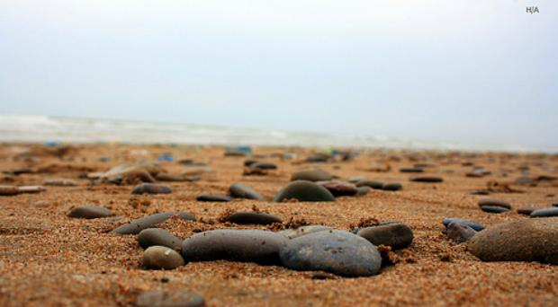

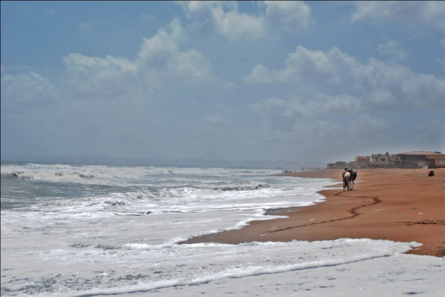

The Sandspit Beach is also a nesting ground for Green and Olive Ridley Turtles, implemented by the Sindh Wildlife Department over the past two decades. Nesting takes place in early winter months. In recent years the WWF-Pakistan has also become involved in turtle conservation activities by establishing a Wetland Centre at the Sandspit beach.